MOU’s of IIPER

Evonext Healthcare Pvt. Ltd.
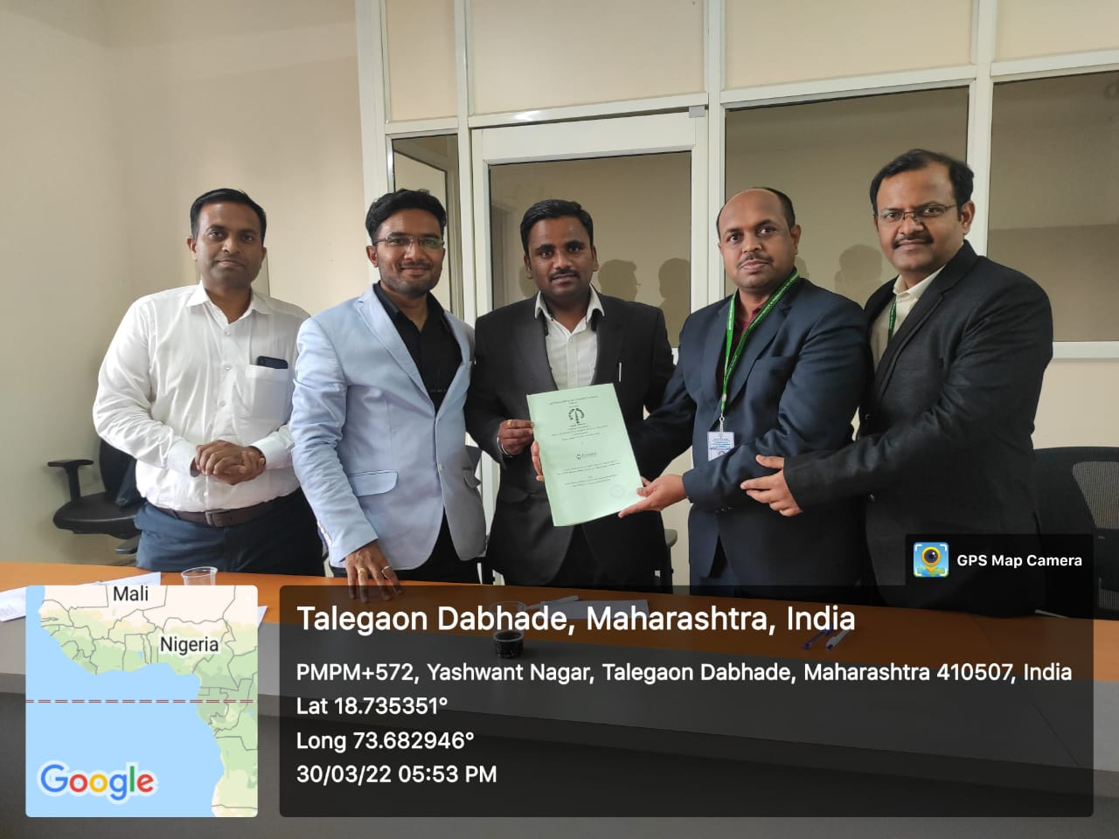

Mr. Shyam.S.Awate Dr. Yogesh B. Zambare Dr. Sanjay R. Arote
TPO IQAC Head Principal

LIST OF MOU’s

Sr. No. | Company Name | Company Address | Duration of MOU | Company Signatory
1 | Varma Pharmacy Pvt.Ltd.  | 59, Industrial Estate, Hadapsar,Pune,  Email: vppl36@gmail.com | 12.09.17- 11.09.20 | Mr. Varma, Director
2 | Generic Healthcare Pvt. Ltd   | Generic Healthcare Pvt. Ltd.  29/a, Shivajinagar, City Square., 2nd Floor. Pune – 411005.  Contact: export@ghpl.co | 18.05.23- 17.05.26 | Mr.Deshmukh Project Head
3 | Vagmine Healthcare Pvt. Ltd.   | 390/1, Rajland Lake View Colony, Talegaon Dabhade, Maval, Pune, Maharashtra, Pin-410506  Email: Sales@Vagminehealthcare.Com | 01.09.20- 30.08.23 | Mr.Amarjit Dhalpe, Director
4 | Sovarian Clinical Research   | Bibvewadi, Pune | 01.09.21- 30.08.24 | Mrs. Hemlata Chavan, Director
5 | Inventia Healthcare | B T Kawade Road, Pune | 01.09.21- 30.08.24 | Dr. Seema Kawade, Director
6 | Ingenious Healthcare   | Hadapsar, Pune | 01.09.21- 30.08.24 | Ms. Parnavi Salve, Director
7 | Evonext Healthcare Pvt. Ltd.   | Shop no.2, Sai Krushna, S. No. 16/2/29, Ambegaon Pathar, Haveli, Pune, Maharashtra- 411046 | 30/03/2022  Forever till dicontinued | Mr. Shivam R. Banarase, M.D. & Mr. Ganesh B. Pete, Co-founder & Business Head
8 | Pawana Hospital, Talegaon   | Somatne Phata,Tal-Maval, Dist- Pune-410507 | 01/10/2022-30/09/2027 | Dr. Satyajit Wadhokar
9 | Talegaon General Hospital   | Talegaon Dabhade,  Tal-Maval, Dist-  Pune-410507 | 17/09/2022- 16/09/2027 | Hon. Shri. Shailesh K. Shah
10 | Skill Academy by Testbook   |  | 7/10/2022-  6/10/2023 | Mr. Ashutosh Kumar
11 | Prado Preclinical Research and Development Organization Pvt. Ltd.   | Urse, Pune | 4/11/2022-  Forever till dicontinued | Dr. Wangikar
12 | Rubicon Skill Development Pvt. Ltd.   | Pune | 12/01/23-  11/01/24 | Mr. Pravir Kumar, CEO& ms. Dipika patil, Asst. Manager
13 | CSAS Programming Inc. | Mumbai | 30/01/23  Forever till dicontinued | Mr. Rohankumar A. Borade
14 | Magic Bus India Pvt. Ltd.   | Pune | 1/4/23  Forever till dicontinued | Ms. Jyoti Waghchaure
15 | Premium Serums and Vaccines Pvt. Ltd.   | Narayangaon, Pune | 15/04/23  Forever till dicontinued | Dr. Nitin Salvi
16 | Shri Swami Samarth Institute of Pharmacy   | Malvadi(Bota), Tal- Sangamner, Dist- Ahmednagar 422602 | 4/11/2023-  3/11/2024 | Dr. Ramdas B. Rode
17 | Wp/Pili/Lakshapathiya Shikshadana  Mahavidyalaya | Shri Maha Vihar Road Lakshapathiya,  Moratuwa- 10400, Shrilanka | 21/12/2023-  20/12/2026 | Mrs. Gunawardhana
18 | Lions club of Colombo Elvitigala | Lion club of Colombo Elvitigala, district  306C2 Shrilanka | 21/12/2023-  20/12/2026 | Mr. Prabha Manjusri Dharmaratne
19 | Maharashtra Institute of Medical Education & Research medical college  & Dr. BSTR Hospital | Talegaon Dabhade , Pune Maharashtra 410507 | 25/01/2024- 24/01/2025 | Mrs. Sandhya Kulkarni  Principal
20 | St. Josephs Secondary School. | Shiksha marg, Biratnagar, Nepal | 1/4/2024- 31/03/2027 | Mr.AmanSitoula  Managing director
21 | Kathmandu International school   | Guheshwori,Kharibot, Kathmandu, Nepal ,  44600 | 29/04/2024- 28/04/2027 | Mr. Pratik Kaiki  Chief administrator
22 | Human harmony Nepal   | Kathmandu 44600, Nepal | 1/4/2024-  31/03/2027 | Namita Ghimire  CEO

Mr. Shyam.S.Awate Dr. Yogesh B. Zambare Dr. Sanjay R. Arote
TPO IQAC Head Principal

